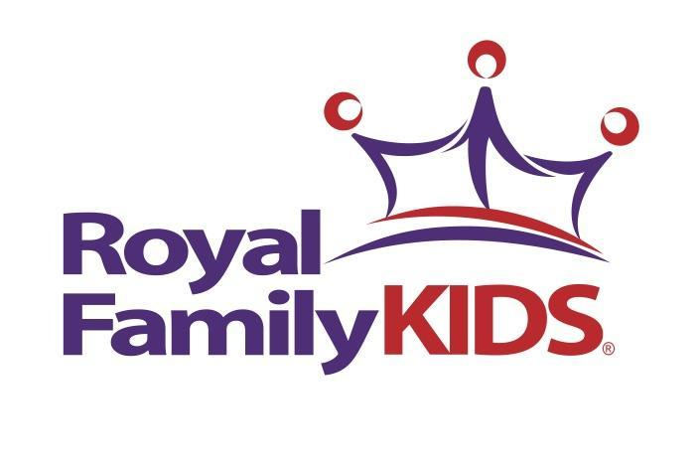

Dear Family and Friends,

This summer I have volunteered to go to a very special camp! This camp provides some amazing children from our community with a week full of fun and special memories.

Our camp is known as Royal Family KIDS Camp. The campers come from the Los Angeles County Foster Care System. Most of the children we bring to camp have experienced the trauma of abuse, abandonment, and neglect and all have suffered a loss when removed from their homes. The children will experience many “firsts” at camp such as swimming in a pool, fishing, hiking, making S’mores and so much more.

Royal Family KIDS Camp is free to foster parents and caregivers. This camp not only serves the children but also offers their caregivers a week of respite. As a volunteer, I am required to raise funds to cover the cost of bringing kids to camp. Would you please commit to praying for our camp and also consider financially partnering with us to make camp possible? My goal is to raise $600.00.

We will be leaving for camp on July 11 and returning on July 16. If you would like to donate you can do so one of two ways:

- Send a check, payable to Kings Harbor Church, in the enclosed self-addressed stamped envelope.
OR
- Donate online at https://www.kingsharbor.org/serve/local/royal-family-kids/

The money we raise provides for cabins, meals, transportation, supplies for our many activities and so much more. I am counting down the days until the kids arrive at camp and know that God will provide for and bless our week!

Thank you,

All donations are tax deductible; your canceled check is your receipt. Please make checks payable to King’s Harbor Church. If necessary, you may contact KHC for the church’s tax identification number at (310) 376-6555.

